Predicting Daily Productivity in Minecraft Mod Development Through Personal Habits and Caffeine Regulation
Karl Satchi E. Navida
College of Computing and Information Technology
National University Philippines
navidake@students.national-u.edu.ph

Abstract — This study examines the relationship between personal habits and daily mod development productivity over a 70-day longitudinal period through a single-subject observational design. Daily data spanning caffeine intake, sleep duration, work session timing, deadline pressure, and psychological ratings (mood, energy, focus, motivation) were collected concurrently with the active development of Defensive Measures, a published Minecraft Java-Fabric modification. Three hypotheses were tested: that caffeine would show no significant correlation with productivity given high habitual tolerance (H1); that night sessions (7 PM–7 AM) would outperform daytime sessions (H2); and that elevated deadline pressure would displace voluntary development hours (H3). None were supported in their predicted form. A marginally significant positive caffeine–productivity correlation (r = 0.352, p = 0.048, active days only) was attributed to common-cause bias rather than a direct effect, with caffeine contributing a near-zero regression coefficient (β = +0.001) when psychological variables were controlled. H2 could not be evaluated due to an insufficient daytime comparison group, with 87.5% of active sessions beginning in nocturnal hours. H3 showed the correct directional trend (r = −0.194) but failed significance due to chronically elevated deadline pressure throughout the study period. Multiple linear regression (R² = 0.32, RMSE = 2.97 hrs) identified Focus Quality (β = +1.176) and Motivation Level (β = +0.498) as the dominant productivity predictors, with Mood Rating and Energy Level showing negligible influence. Findings suggest that for an intrinsically motivated solo developer, productivity is primarily driven by psychological engagement with the work rather than by external habit variables, with deep focus emerging as the single most actionable predictor of daily output.
Index Terms—Mod Development, Minecraft Modding, Developer Productivity, Personal Habits, Caffeine Regulation, Caffeine Tolerance, Daily Metrics, Chronotype, Deadline Pressure, Single-Subject Study, Self-tracking
- INTRODUCTION
Background of the Study
Software development productivity has long been a subject of inquiry in both industry and academia, yet the majority of existing research focuses on team-based, enterprise software environments. The solo independent developer, particularly one engaged in voluntary, passion-driven projects, remains a largely understudied subject. This gap becomes more pronounced when the developer operates outside conventional work schedules, relying on self-regulation of habits such as sleep and caffeine intake rather than institutional structure.
Caffeine is one of the most widely consumed psychoactive substances globally, and its role in cognitive performance has been extensively studied in controlled laboratory settings. However, its practical effect on real-world programming productivity especially among individuals who have developed high habitual tolerance is less understood. Similarly, while chronotype research has established that evening-type individuals may demonstrate cognitive advantages during late-night hours, how this translates to programming output in an authentic development context remains an open question.
This study addresses these gaps through a single-subject, longitudinal observational design spanning 70 days (March 1 to May 9, 2026), tracking the development of Defensive Measures, a published Minecraft Java-Fabric modification. The researcher, a night-owl developer with high caffeine tolerance and a self-directed work pattern, served as both subject and investigator. Daily data collection captured mod development hours, caffeine intake, sleep duration, subjective psychological ratings (mood, energy, focus, motivation), git commits, deadline pressure, and work session timing resulting in a comprehensive personal productivity dataset.
Statement of the Problem
Despite the growing population of independent game developers and modders who operate outside traditional software development environments, little empirical data exists on the factors that predict their daily productivity. Informal productivity advice often assumes morning-optimal schedules, moderate and consistent caffeine use, and team-based accountability structures, which are conditions that systematically do not apply to solo night-owl developers.
This study asks: which personal habit factors meaningfully predict daily mod development productivity, specifically caffeine intake, sleep duration, and work session timing, and to what degree does deadline pressure suppress or redirect development effort?
Research Objectives
The primary objective of this study is to identify which combination of sleep quality, caffeine consumption patterns, and work session structure best predicts daily code commits and feature completion rates during Defensive Measures mod development.
The secondary objectives are as follows:
Caffeine Tolerance Effect: To determine whether regulated caffeine intake still correlates with productivity given the subject's pre-existing high habitual tolerance.
Chronotype vs. Environment: To analyze whether late-night work sessions (7 PM–7 AM) produce higher productivity metrics compared to daytime sessions, and whether any such advantage is attributable to chronotype or to reduced environmental interruptions.
Burnout Indicators: To explore temporal patterns in mood, energy, focus, and motivation ratings across the 70-day period to identify potential early indicators of burnout or productivity decline.
Deadline Displacement Effect. To investigate whether days with elevated deadline pressure suppress voluntary mod development hours, reflecting a displacement of discretionary effort by institutional obligations.
Hypotheses
H1 (Caffeine–Productivity). Caffeine intake (coffee and tea combined) will show no significant correlation with mod development productivity metrics, owing to the subject's established high habitual tolerance and the deliberate reduction in caffeine consumption undertaken during the data collection period.
H2 (Chronotype–Productivity). Work sessions occurring within the 7 PM–7 AM window will be associated with higher productivity output compared to daytime sessions. It is noted that cross-midnight sessions — logged to the calendar day on which they began — introduce a systematic complexity into day-of-week analysis that must be interpreted carefully.
H3 (Deadline Displacement). Days with higher recorded deadline pressure scores will be associated with lower mod development hours, reflecting the displacement of voluntary creative work by urgent academic or professional obligations.
Scope and Limitations
This study covers a 70-day observation period from March 1 to May 9, 2026, encompassing the development of a single software project by a single subject. The self-reported nature of several variables (mood, energy, focus, motivation, caffeine intake) introduces inherent subjectivity, and the single-subject design limits generalizability beyond the individual case. Qualitative context recorded in field notes is excluded from all formal analyses and outputs to preserve privacy.
The deliberate reduction in caffeine intake during the study period undertaken for health reasons independent of the study and is acknowledged as a confounding variable for H1 and is discussed accordingly in the methodology and results sections.
Significance of the Study
The findings of this study contribute a data-driven, ecologically valid account of productivity factors for a solo evening-chronotype developer — a profile common among independent developers and modders but rarely represented in academic productivity literature. For the subject personally, the results offer actionable insights into which habits and conditions are genuinely associated with productive development sessions versus those that are merely habitual assumptions. More broadly, this work demonstrates a replicable self-tracking methodology that other independent developers could adapt to study their own productivity patterns.
- LITERATURE REVIEW
Developer Productivity Measurement
Productivity in software development has historically resisted simple quantification. Forsgren et al. [1] proposed the SPACE framework as a response to this challenge, arguing that developer productivity must be understood across five interdependent dimensions: Satisfaction and well-being, Performance, Activity, Communication and collaboration, and Efficiency and flow. A central claim of the framework is that no single metric — not commit count, not lines of code, not hours logged — is sufficient to capture the full picture of a developer's output. The authors argue that meaningful productivity assessment must combine objective behavioral metrics with subjective psychological measures.
This study operationalizes that multi-dimensional approach at the individual level. Objective metrics — mod development hours, git commits, and tasks completed — are paired with daily subjective ratings of mood, energy, focus, and motivation to construct a more complete productivity profile. While the SPACE framework was developed with team-based software environments in mind, its core principle that productivity is inherently multi-dimensional translates directly to the solo development context, where the developer must self-manage all dimensions without institutional scaffolding.
Caffeine, Tolerance, and Cognitive Performance
Caffeine is the most widely consumed psychoactive substance in the world, and its short-term cognitive benefits — improved alertness, faster reaction time, and reduced mental fatigue — are well documented. However, the degree to which these benefits persist under conditions of high habitual consumption remains an open question. Kapellou et al. [2] investigated caffeine-gene interactions on cognitive performance among habitual consumers, finding that genetic metabolizer type significantly moderated caffeine's effects on social cognition and executive function. Critically, their findings suggest that habitual intake patterns interact with individual biology to shape cognitive outcomes, meaning the cognitive effect of a given dose is not uniform across people or across consumption histories.
For this study, these findings directly inform H1. The subject's years of intensive caffeine use represent a well-established habitual consumption pattern, and the deliberate reduction in intake undertaken during the 70-day collection period introduces an additional confound. Rather than reflecting a controlled caffeine manipulation, the caffeine data captured here represent naturalistic variation under tolerance conditions making a null or near-null correlation with productivity the expected, theoretically grounded outcome rather than a surprising one.
Chronotype and Work Session Timing
The assumption that morning work hours are universally optimal for productive cognitive work has been increasingly challenged by chronotype research. West et al. [3], analyzing data from 26,820 participants aged 53–86 in the UK Biobank, found that evening chronotypes outperformed morning types on standardized cognitive assessments, with normal sleep duration of 7–9 hours associated with the strongest performance across all chronotype groups. These results suggest that the cognitive advantage commonly attributed to morning routines in popular productivity discourse may reflect a morning-chronotype bias rather than a universal truth.
This study extends that line of inquiry into an applied programming context. The subject is a self-identified and behaviorally confirmed night owl, with peak voluntary work sessions consistently occurring in the late evening and early morning hours. H2 predicts that sessions falling within the 7 PM–7 AM window will be associated with higher productivity output — not merely because of chronotype, but also because late-night hours reduce household interruptions that fragment concentration during daytime hours. A methodological note is necessary here: cross-midnight sessions are logged to the calendar day on which they began, which means day-of-week analyses carry a systematic temporal complexity that requires careful interpretation.
Deadline Pressure and Discretionary Work Displacement
The relationship between deadline pressure and creative productivity is not straightforward. Zhang et al. [4], in a study of 203 employees across multiple organizations published in the Journal of Organizational Behavior, found that time pressure affects radical and incremental creativity differently, with planning capacity moderating how much deadline pressure degrades novel creative output. More broadly, research summarized from Amabile's longitudinal workplace studies found that while time pressure may drive people to work more and feel more productive, it generally causes them to think less creatively — a pattern described as creativity being "killed" when under the gun.
In the context of this study, deadline pressure operates through a different but related mechanism: displacement rather than within-task degradation. The subject's deadlines during the 70-day collection period were primarily academic and professional in nature — thesis submissions, school requirements, and LGU work obligations — which are categorically distinct from mod development. When such obligations intensify, voluntary discretionary work on Defensive Measures is the activity most likely to be deferred, not because creativity is impaired but because competing time demands leave no available hours. This displacement framing is supported by the dataset itself: the Other_Deadlines_Present variable recorded a mean score of approximately 2.96 across all 70 days, placing the average day solidly in the "Critical — due this week" range, indicating that deadline pressure was not an occasional disruption but a persistent background condition throughout the study period.
- METHODOLOGY
Research Design
This study employs a single-subject, longitudinal observational design spanning 70 consecutive days from March 1 to May 9, 2026. The researcher served as both subject and investigator, tracking daily personal habits and mod development productivity metrics during the active development of Defensive Measures, a published Minecraft Java-Fabric modification. Given the inherently individual nature of the research questions, which concern the interaction between a specific developer's chronotype, caffeine tolerance, and work habits, a single-subject design is appropriate and intentional rather than a limitation of access. All data were collected prospectively on a daily basis.
Participant
The participant is the researcher, a 26-year-old graduating Bachelor of Science in Computer Science (specialization: Machine Learning) student residing in Rizal province, Philippines. The subject is a self-taught programmer since age 14 with years of intensive caffeine use, a confirmed evening chronotype with peak voluntary productivity between 10 PM and 6 AM, and a full-time Job Order (contractual) Webmaster at a local government unit (LGU). The subject is the sole developer and publisher of Defensive Measures, which is actively distributed on Modrinth and Curseforge. Data collection occurred concurrently with the subject's final academic semester, which included ongoing thesis, internship, and coursework obligations throughout the study period.
Data Collection
Data were recorded daily in a Microsoft Excel spreadsheet, with supplementary automated tracking via GitHub commit logs. Cross-midnight sessions were assigned to the calendar day on which they began. The dataset comprises 18 variables across 70 observations, covering the following domains:
Productivity Metrics. Mod development hours (Mod_Development_Hours) tracked voluntary, motivation-driven work on Defensive Measures exclusively, captured via screen recording timestamps. This is the primary dependent variable. Git commits (Git_Commits) and tasks completed (Tasks_Completed) served as secondary productivity indicators. Total programming screen time (Programming_Screen_Time) captured all programming contexts including office work and academic tasks.
Caffeine Intake. Coffee (Coffee_Intake, 0–2 mugs) and tea (Tea_Intake, 0–4 mugs) were recorded separately as daily totals. All beverages were consumed from a single insulated stainless-steel mug (LLDA-issued, inner diameter 8.6 cm, inner height 11.5 cm, volumetric capacity approximately 668.4 mL) filled to an estimated 85–90% capacity, yielding an effective fill volume of approximately 584.9 mL per serving. A derived variable Total_Caffeine_mL was computed as the product of total daily mug count and fill volume, providing a volumetrically grounded caffeine intake estimate. It is noted that caffeine intake was recorded as a daily total rather than session-specific consumption, capturing drinks consumed across all contexts including office work, gaming, and daily routines, not exclusively during mod development sessions.
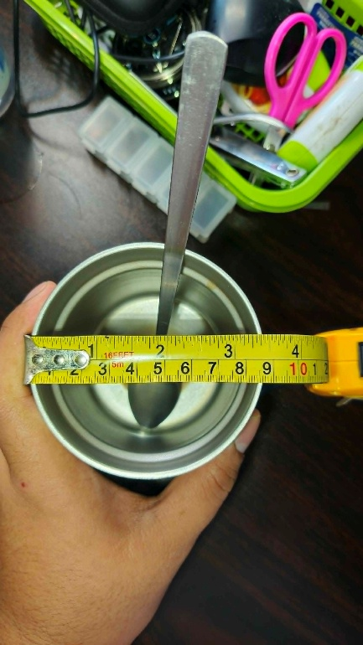
Figure 1: The diameter measurement for the "cup" used by the subject.
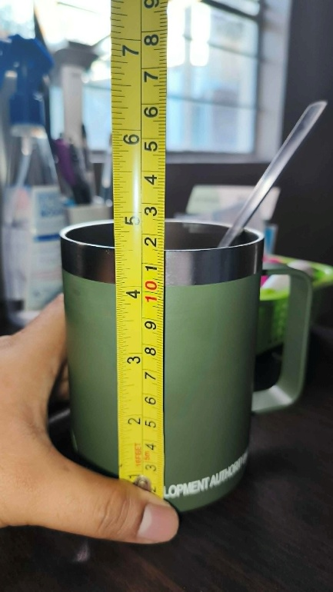
Figure 2: The height measurement for the "cup" used by the subject.
Sleep. Main sleep duration (Sleep_Duration) was recorded in hours, representing the primary nightly sleep episode only.
Psychological Ratings. Mood (Mood_Rating), energy (Energy_Level), focus (Focus_Quality), and motivation (Motivation_Level) were each recorded daily on a five-point Likert scale (1 = very low, 5 = very high).
Work Session Structure. Session start and end timestamps (Work_Session_Timing) were extracted from screen recordings. Sessions were classified into four temporal quarters using a predefined dictionary (SESSION_PERIODS): Early Morning (12:00 AM–5:59 AM), Morning (6:00 AM–11:59 AM), Afternoon (12:00 PM–5:59 PM), and Evening (6:00 PM–11:59 PM). A binary variable Is_Night_Session was derived, marking sessions beginning in the Evening or Early Morning quarters as night sessions for hypothesis testing purposes.
Deadline Pressure. A single ordinal variable (Other_Deadlines_Present) captured the highest-priority external deadline present on each day, scored from 1 (Minor — postponable) to 5 (Top Priority — due same day). Only the highest active priority was recorded per day for simplification.
Data Cleaning and Preprocessing
Raw data were loaded into a Jupyter Notebook environment using Python 3 with pandas. An original copy of the dataframe (ogDf) was retained throughout analysis as an untouched reference, with all transformations applied to a working copy (df). Date strings were parsed to datetime format. The Notes column was excluded from all analyses and outputs to preserve privacy.
Missing values in Work_Session_Timing (n=38) and Primary_Focus_Area (n=38) corresponded exclusively to zero mod development days and were retained as structurally valid rather than imputed. For visualization and grouping purposes these fields were filled with the label "No Session."
Statistical Analysis
All statistical analyses were conducted in Python 3.9 using pandas (data manipulation), scipy.stats (hypothesis testing), scikit-learn (regression modeling), and matplotlib/seaborn (visualization). The significance threshold was set at α = 0.05 for all tests.
Descriptive Statistics. Means, standard deviations, minima, and maxima were computed for all continuous variables across both the full 70-day dataset and the active-days-only subset (n=32, days where Mod_Development_Hours > 0), given that zero-day observations substantially skew productivity means.
H1 — Pearson Correlation (Caffeine vs Productivity). Pearson correlation coefficients were computed between Total_Caffeine_mL and Mod_Development_Hours for both the full dataset and the active-days-only subset, given the structural inflation of the zero-day correlation by non-development days.
H2 — Independent Samples t-test (Night vs Day Sessions). An independent samples t-test (one-tailed) compared mean mod development hours between night sessions (Is_Night_Session = True, n=28) and day sessions (Is_Night_Session = False, n=4) among active days only. The severe sample imbalance (87.5% night vs 12.5% day) is acknowledged as a fundamental constraint on the interpretability of this test.
H3 — Pearson Correlation (Deadline Pressure vs Productivity). Pearson correlation was computed between Other_Deadlines_Present and Mod_Development_Hours across all 70 days. Descriptive analysis of mean mod dev hours by deadline score group was conducted as a supplementary examination.
Correlation Matrix. A full Pearson correlation matrix was computed across all key variables to examine inter-variable relationships beyond the primary hypotheses.
Regression Modeling. A multiple linear regression model was fit using Total_Caffeine_mL, Sleep_Duration, Mood_Rating, Energy_Level, Focus_Quality, Motivation_Level, and Other_Deadlines_Present as predictors of Mod_Development_Hours. Model performance was evaluated using the coefficient of determination (R²) and root mean squared error (RMSE).
Ethical Considerations
All data were collected by and about the researcher exclusively. Personal habit data are reported only in aggregate form. The Notes column containing qualitative daily context was excluded from all outputs and analyses. Screen recordings were deleted after timestamp extraction unless retained by the subject for independent content purposes. The data present minimal ethical risk as they consist of non-sensitive personal habits and programming metrics collected within a self-study framework.
- RESULTS
Descriptive Statistics
Over the 70-day collection period, mod development activity was recorded on 32 days (45.7%), with the remaining 38 days (54.3%) producing zero mod development output. Across all 70 days, the mean daily mod development hours was 2.60 hours (SD = 3.63), reflecting the skewing effect of zero-day observations. Among active days only (n = 32), the mean rose to 5.70 hours (SD = 3.34), with a minimum of 0.15 hours and a maximum of 12.40 hours.
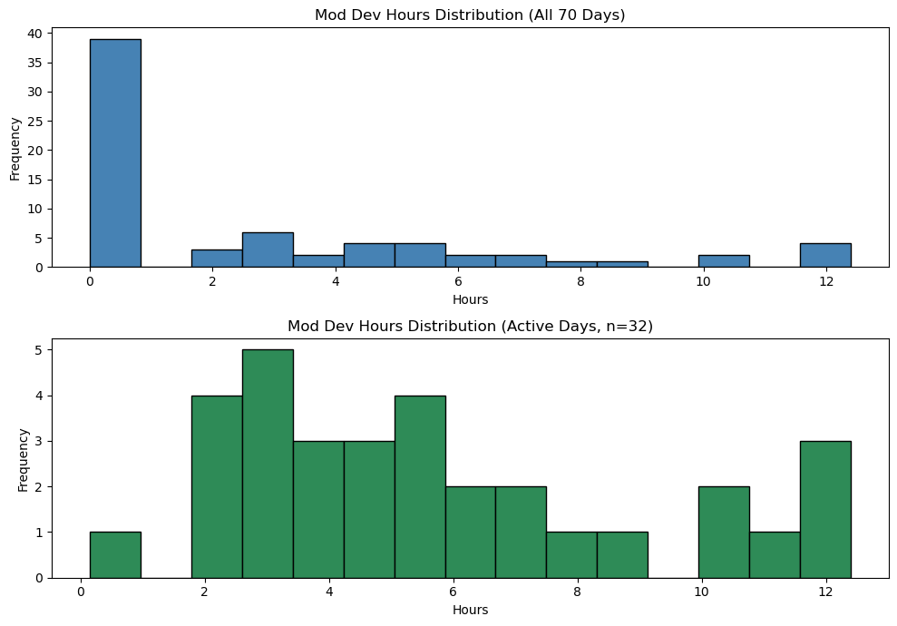
Figure 3: Mod Dev Hours Distribution
Table 1 presents descriptive statistics for key variables stratified by all days and active days.
Variable | All Days (n=70) Mean | All Days SD | Active Days (n=32) Mean | Active Days SD
Mod Dev Hours | 2.60 | 3.63 | 5.70 | 3.34
Sleep Duration | 4.94 | 2.91 | 4.00 | 2.89
Coffee Intake (mugs) | 1.79 | 1.64 | 2.44 | 1.65
Mood Rating | 3.09 | 1.09 | 3.13 | 1.29
Energy Level | 2.56 | 1.03 | 2.59 | 1.16
Focus Quality | 2.50 | 1.05 | 2.88 | 1.19
Motivation Level | 2.76 | 1.14 | 3.00 | 1.37
Deadline Pressure | 2.96 | 1.14 | 2.69 | 1.26
Git Commits | 0.36 | 0.74 | 0.75 | 0.95
Tasks Completed | 0.59 | 1.11 | 1.28 | 1.35
Table 1: Descriptive Statistics by Dataset Scope
Deadline pressure showed a notably compressed distribution, with a mean of 2.96 (SD = 1.14) across all 70 days. The median and interquartile range both sat at 3.00, indicating that Critical pressure (score = 3) was the dominant daily condition throughout the study. Specifically, 55 of 70 days (78.6%) recorded a deadline pressure score of 3 or above, and only 3 days (4.3%) registered at Moderate (score = 2) — indicating an effectively bimodal distribution between Minor (score = 1) and Critical (score = 3) with virtually no moderate-pressure baseline.
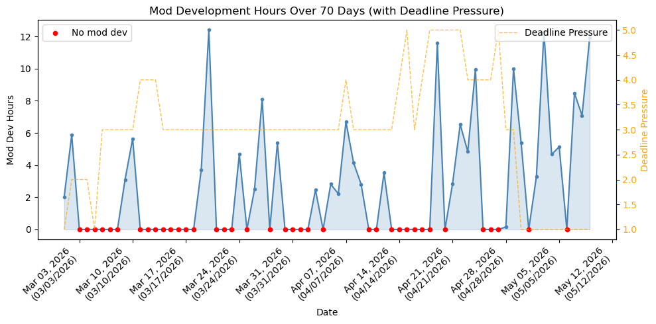
Figure 4: Mod Dev Hours + Deadline Pressure Time Series
Session Period Distribution
Of the 32 active development days, 28 sessions (87.5%) were classified as night sessions (Evening or Early Morning start), while only 4 sessions (12.5%) were classified as day sessions (Morning start; no Afternoon sessions were recorded). Within the night session group, 23 sessions (71.9% of all active days) began in the Early Morning quarter (12:00 AM–5:59 AM), and 5 sessions (15.6%) began in the Evening quarter (6:00 PM–11:59 PM). This distribution confirms the subject's strongly nocturnal development pattern across the study period.
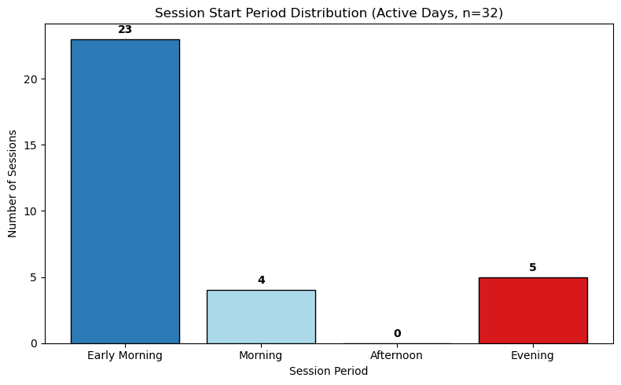
Figure 5: Session Period Distribution
Deadline Distribution
Deadline pressure showed a notably compressed distribution across the 70-day period (M = 2.96, SD = 1.14). As illustrated in Figure 4, the distribution was effectively bimodal — 12 days (17.1%) registered at Minor pressure (score = 1), while 38 days (54.3%) sat at Critical pressure (score = 3), with only 3 days (4.3%) at Moderate (score = 2). Days at Urgent (score = 4, n = 10) and Top Priority (score = 5, n = 7) accounted for the remaining 24.3%. This compressed distribution — with virtually no moderate-pressure baseline — is a structural characteristic of the dataset that directly constrains the interpretability of H3.
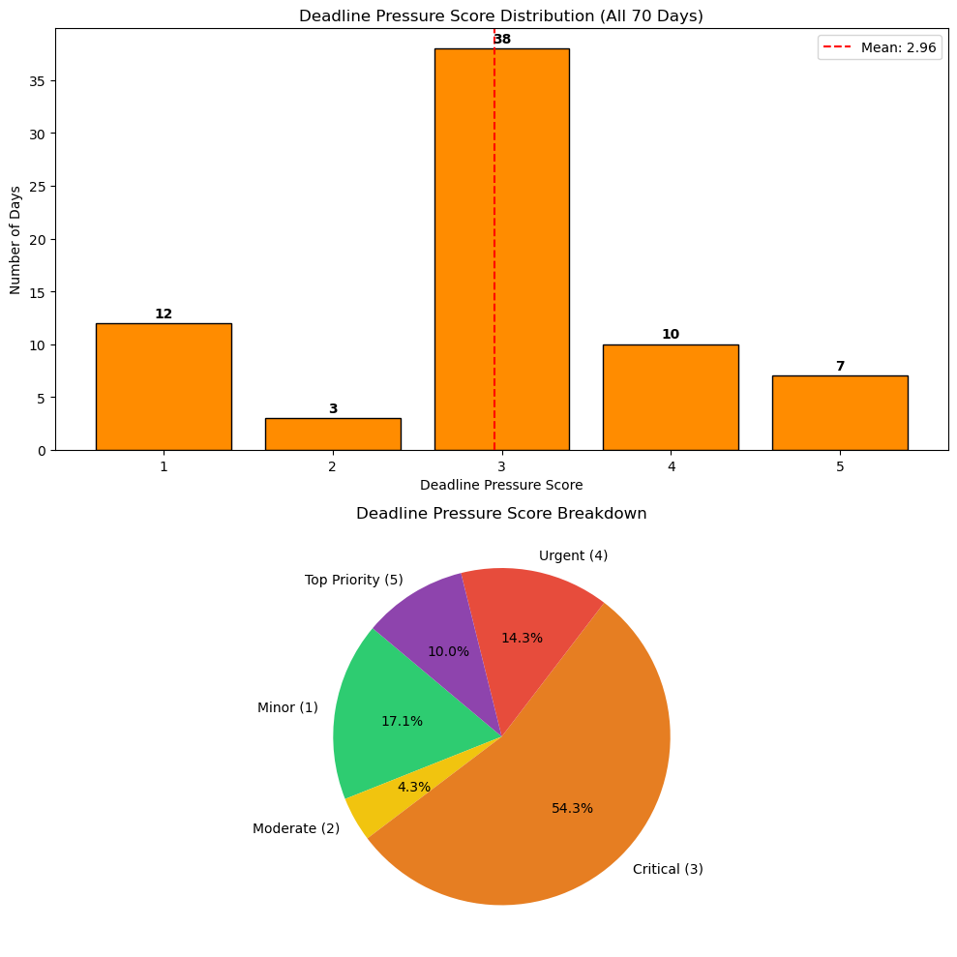
Figure 6: Deadline Pressure Distribution
Hypothesis Testing
H1 — Caffeine Intake and Productivity: Pearson correlation analysis across all 70 days revealed a statistically significant positive correlation between total caffeine intake (mL) and mod development hours (r = 0.4158, p = 0.0003). However, this result is substantially influenced by the structural presence of 38 zero mod development days, during which caffeine was still consumed across other daily contexts (office work, gaming, daily routines).
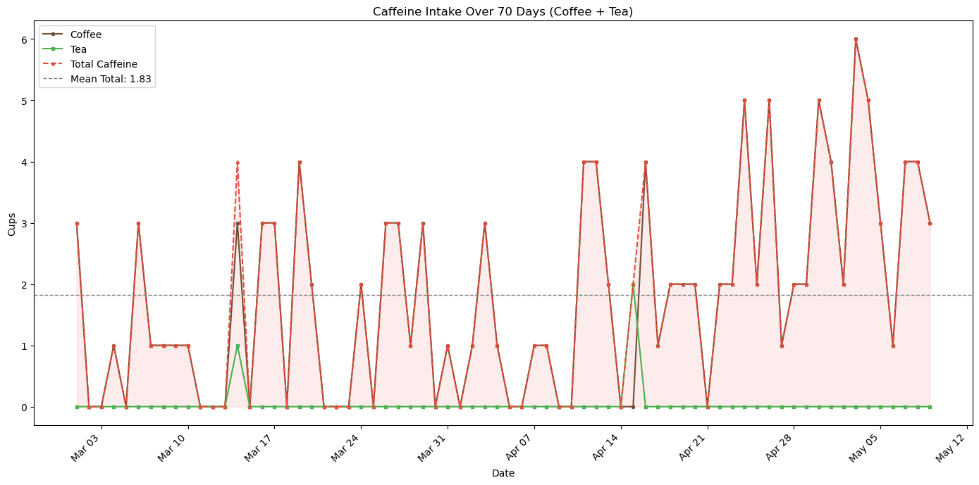
Figure 7: Caffeine Intake Over Time
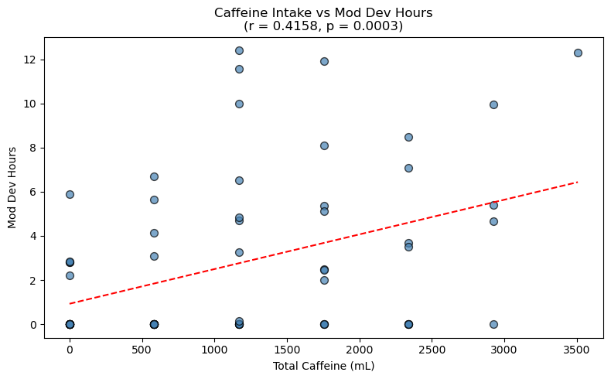
Figure 8: Caffeine vs Mod Dev Hours
Re-analysis restricted to active days only (n = 32) yielded a reduced but marginally significant correlation (r = 0.3521, p = 0.0481). Despite technical significance at α = 0.05, this result is interpreted with caution for three reasons: (1) the p-value is at the boundary of the significance threshold; (2) caffeine intake was recorded as a daily total rather than session-specific consumption, limiting causal interpretability; and (3) the observed positive direction likely reflects a common-cause relationship in which the intention to conduct a productive development session drives both higher caffeine consumption and higher mod development hours simultaneously, rather than caffeine causing productivity. Furthermore, the regression model assigned a near-zero coefficient to Total Caffeine mL (β = +0.001) when controlling for psychological variables, providing the strongest evidence against a direct caffeine–productivity relationship.
H1 is not supported in its predicted direction. Rather than confirming a null relationship, the data reveal a marginally significant positive correlation that is most parsimoniously explained by confounding factors including common-cause bias, daily-total measurement granularity, and the deliberate caffeine reduction undertaken during the study period.
H2 — Night vs Day Session Productivity: An independent samples t-test (one-tailed) comparing mod development hours between night sessions (n = 28, M = 5.53 hrs, SD = 3.36) and day sessions (n = 4, M = 6.84 hrs, SD = 3.39) found no statistically significant difference (t = −0.7262, p = 0.2367). Contrary to the hypothesis, day sessions produced a numerically higher mean, though this result must be interpreted with extreme caution.
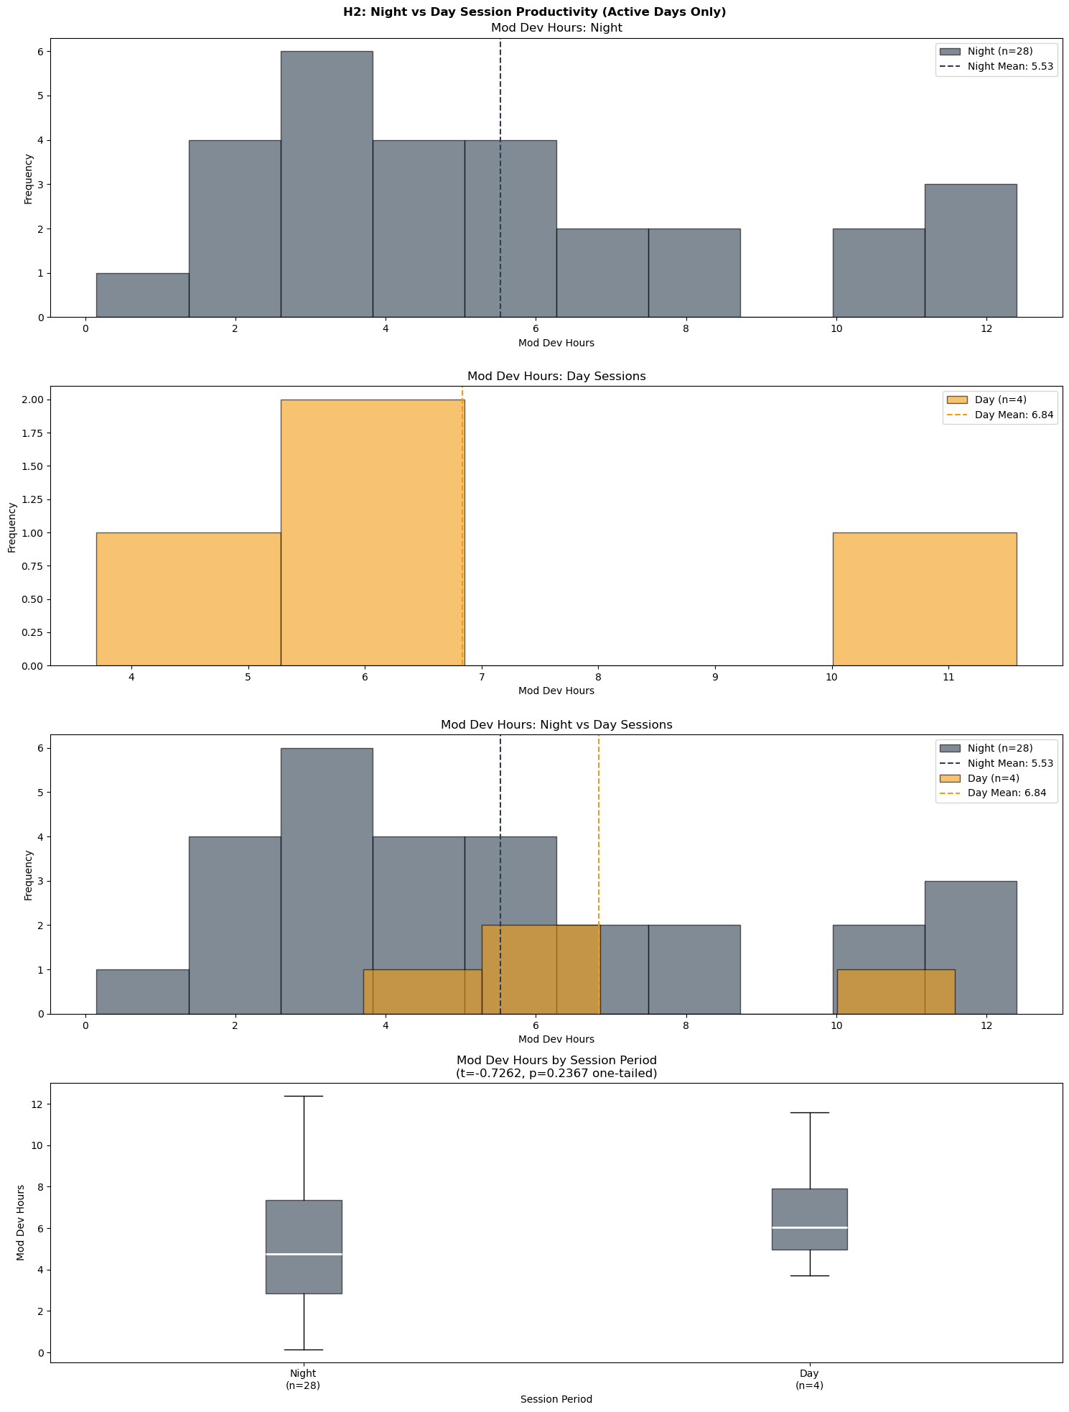
Figure 9: Night vs Day Session Productivity
The day session group (n = 4) is critically underpowered for meaningful statistical comparison, representing only 12.5% of active days. Furthermore, the 4 day sessions are likely not genuinely daytime-initiated sessions but rather cross-midnight extensions from the previous evening that continued into Morning hours — a pattern consistent with the subject's documented tendency to extend sessions past midnight. This interpretation is supported by the session period distribution showing zero Afternoon sessions across the entire 70-day period.
H2 is not evaluable with the present dataset. The subject's chronotype is so consistently nocturnal that an adequate daytime comparison group did not emerge naturally during data collection. A future study with deliberately structured daytime sessions would be required to test this hypothesis meaningfully.
H3 — Deadline Pressure and Productivity Displacement: Pearson correlation between deadline pressure score and mod development hours across all 70 days was negative in direction but did not reach statistical significance (r = −0.1942, p = 0.1073). H3 is therefore not supported statistically.
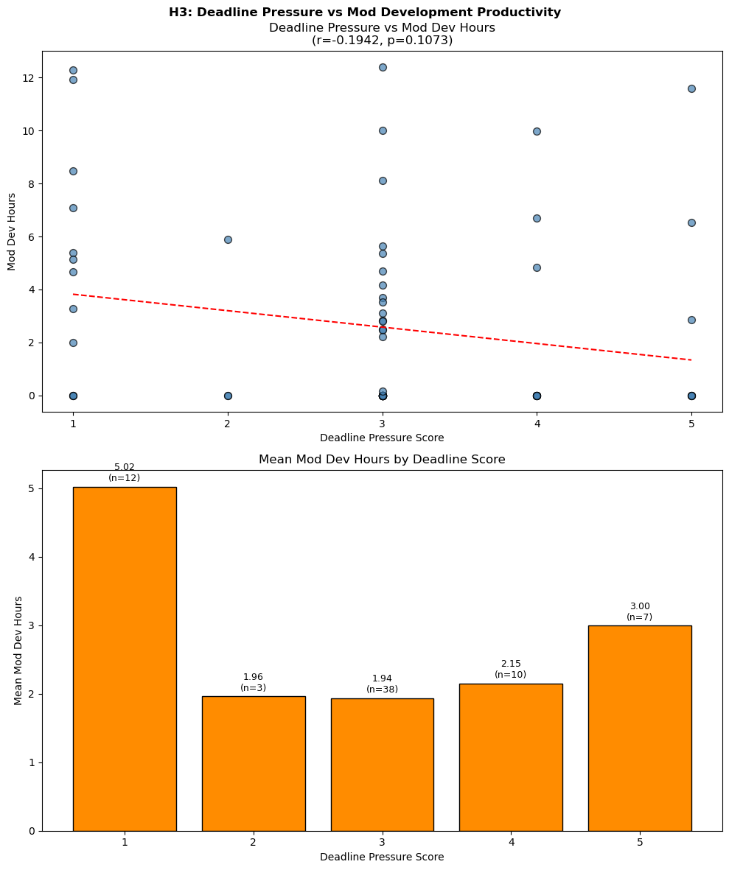
Figure 10: Deadline Pressure vs Mod Development Productivity
However, descriptive analysis of mean mod development hours by deadline score reveals a pattern partially consistent with the displacement hypothesis. Days at Minor pressure (score = 1, n = 12) produced the highest mean output at 5.02 hours. Mean hours collapsed sharply at Moderate pressure (score = 2, n = 3; M = 1.96 hrs) and remained similarly suppressed at Critical (score = 3, n = 38; M = 1.94 hrs) and Urgent pressure (score = 4, n = 10; M = 2.15 hrs). An unexpected uptick was observed at Top Priority pressure (score = 5, n = 7; M = 3.00 hrs), interpreted as a psychological displacement-reversal effect whereby voluntary mod development served as a cognitive retreat on days of peak institutional pressure.
The absence of statistical significance is primarily attributed to the chronic Critical baseline throughout the study period — with 54.3% of days at score = 3 and only 4.3% at score = 2, the dataset lacked sufficient low-to-moderate pressure variation to detect a clean displacement effect statistically. The directional pattern is visible descriptively but cannot be confirmed inferentially given this constraint.
Correlation Matrix
The full Pearson correlation matrix revealed that Tasks Completed (r = 0.633) and Git Commits (r = 0.575) were the strongest correlates of mod development hours, functioning as output validation metrics. Among habit variables, Total Caffeine mL (r = 0.416) showed the highest raw correlation, followed by Focus Quality (r = 0.387) and Motivation Level (r = 0.335). Mood Rating (r = 0.122) and Energy Level (r = 0.056) showed surprisingly weak correlations with productivity output. Sleep Duration (r = −0.266) and Deadline Pressure (r = −0.194) were negatively correlated with mod development hours.
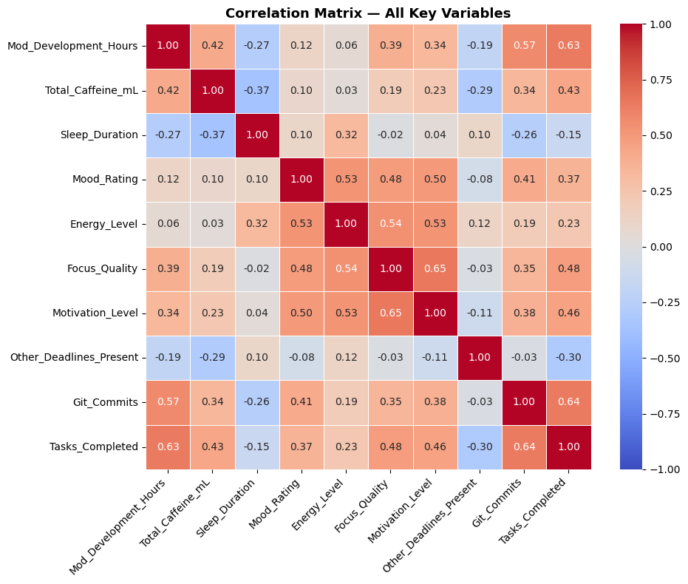
Figure 11: Correlation Matrix Heatmap
Notable inter-variable relationships included a strong coupling between Focus Quality and Motivation Level (r = 0.650), a moderate Mood–Energy correlation (r = 0.530), and a negative Sleep–Caffeine relationship (r = −0.370) consistent with compensatory caffeine use following short sleep. Tasks Completed and Deadline Pressure showed a moderate negative correlation (r = −0.300), providing indirect support for the H3 displacement hypothesis beyond the primary correlation test.
Regression Model
A multiple linear regression model predicting mod development hours from seven habit variables yielded R² = 0.3197 and RMSE = 2.9717 hours, indicating that the model explains approximately 32% of daily productivity variance. The remaining 68% is attributed to unmeasured factors including specific development milestones, feature complexity, intrinsic engagement states, and the positive feedback loop between progress and motivation documented qualitatively throughout the study.
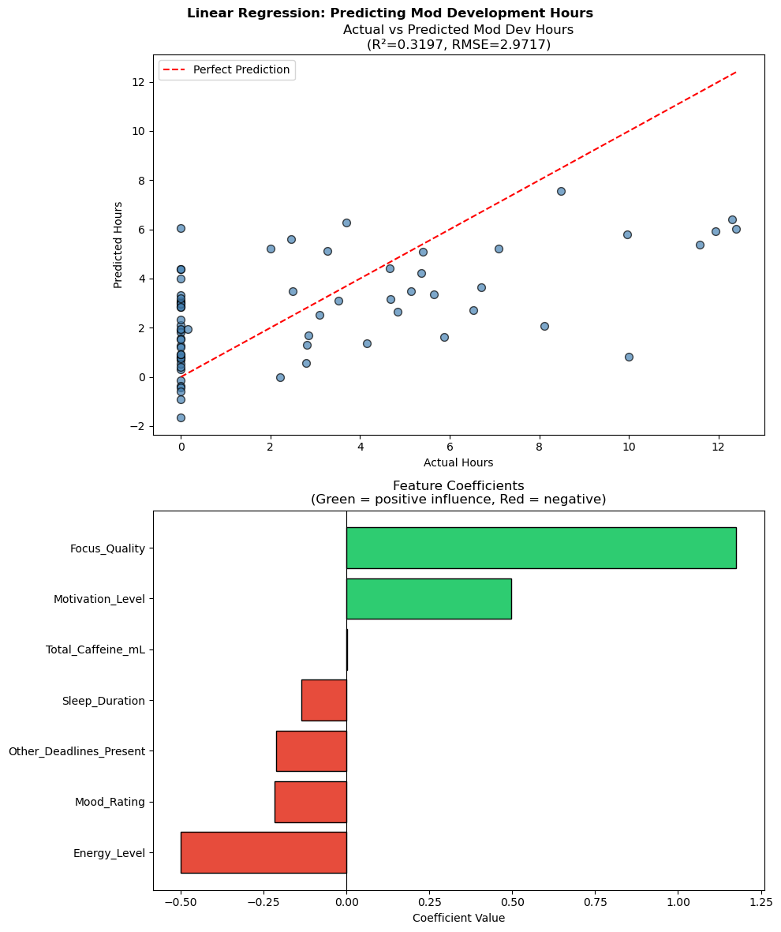
Figure 12: Regression Actual vs Predicted + Coefficients
Focus Quality emerged as the dominant positive predictor (β = +1.176), indicating that each one-point increase in self-rated focus is associated with approximately 1.18 additional hours of mod development. Motivation Level was the second positive predictor (β = +0.498). Total Caffeine mL contributed a near-zero coefficient (β = +0.001), confirming the absence of a direct caffeine effect once psychological variables are controlled. Energy Level (β = −0.500) and Mood Rating (β = −0.217) showed negative coefficients, consistent with the finding that high-energy and positive-mood days are associated with active external obligations rather than home-based development sessions. Deadline Pressure (β = −0.212) and Sleep Duration (β = −0.137) also showed negative coefficients in their expected directions.
- DISCUSSION
Overview
This study examined the relationship between personal habits: caffeine intake, sleep duration, work session timing, and deadline pressure; and daily mod development productivity over a 70-day longitudinal period. Three hypotheses were tested using Pearson correlation, independent samples t-test, and multiple linear regression. None of the three hypotheses were supported in their predicted form, yet each produced findings that are meaningful and interpretable within the specific context of a single nocturnal, intrinsically motivated solo developer operating under chronic academic and professional pressure.
Caffeine and Productivity (H1)
H1 predicted that caffeine intake would show no significant correlation with productivity, given the subject's established high habitual tolerance. The data instead revealed a marginally significant positive correlation on active days (r = 0.352, p = 0.048), technically rejecting the null hypothesis — but not in a direction that supports a causal caffeine–productivity relationship.
The most parsimonious explanation is a common-cause relationship: on the days the subject planned to conduct serious development work, both caffeine consumption and mod development hours increased together in response to the same underlying intention. This interpretation is strongly supported by the regression model, which assigned a near-zero coefficient to Total Caffeine mL (β = +0.001) once psychological variables were controlled — effectively eliminating caffeine as an independent predictor of productivity.
This finding aligns with Kapellou et al. [2], whose work on habitual caffeine consumers demonstrated that individual biology and consumption history significantly moderate caffeine's cognitive effects. For a developer with years of intensive daily caffeine use, the pharmacological signal is largely absorbed into baseline functioning. Additionally, the deliberate reduction in caffeine intake undertaken during the study period for health reasons introduces a confound that further limits interpretability. Taken together, the evidence suggests caffeine functions for this subject primarily as a comfort and routine behavior associated with settling into a work session — a behavioral cue rather than a performance enhancer.
The measurement granularity of caffeine as a daily total rather than session-specific intake further limits interpretation. Table 1 illustrates that active days averaged 2.44 mugs of coffee compared to 1.79 mugs across all days — a difference more likely reflecting the subject's preparation ritual for planned sessions than a dose-response productivity effect.
Chronotype and Session Timing (H2)
H2 predicted that night sessions (7 PM–7 AM) would outperform daytime sessions in productivity. This hypothesis could not be meaningfully evaluated with the present dataset. Of 32 active development days, 28 (87.5%) began in the Evening or Early Morning quarters — leaving only 4 day sessions for comparison, an insufficient sample for valid statistical inference.
The 4 day sessions themselves are likely not genuinely daytime-initiated. Given the subject's documented pattern of cross-midnight sessions, these observations most plausibly represent evening sessions that extended past 6 AM rather than sessions begun during conventional daytime hours. This interpretation is supported by the complete absence of Afternoon-initiated sessions across the entire 70-day period; a developer who never once began coding in the afternoon is unlikely to have begun four sessions in the morning independently.
Paradoxically, the inability to test H2 is itself a meaningful finding. The session period distribution — 71.9% of active days beginning between midnight and 6 AM — provides strong behavioral confirmation of the subject's nocturnal chronotype independent of any productivity comparison. This is consistent with West et al. [3], whose UK Biobank analysis established that evening chronotypes demonstrate genuine cognitive performance advantages during their preferred hours. The present data suggest the subject's nocturnal pattern is not merely habitual but deeply entrenched. So consistently so that a naturalistic study design cannot generate sufficient daytime observations to test the chronotype hypothesis.
Future research addressing H2 would require deliberately structured daytime development sessions, which would themselves introduce an ecological validity trade-off by imposing artificial constraints on a voluntary, intrinsically motivated activity.
Deadline Pressure and Displacement (H3)
H3 predicted that higher deadline pressure would displace mod development hours. While the direct correlation did not reach statistical significance (r = −0.194, p = 0.107), the descriptive pattern partially supports the displacement hypothesis and reveals a more nuanced dynamic.
Minor-pressure days (score = 1, n = 12) produced the highest mean mod development output at 5.02 hours — nearly 2.6 times the mean output on Critical-pressure days (score = 3, M = 1.94 hrs). This collapse in output from score 1 to scores 2–4 is consistent with Zhang et al.'s [4] finding that time pressure degrades discretionary creative output, and with the displacement framework proposed in Chapter 2: when institutional obligations intensify, voluntary development work is the first activity deferred.
The failure to reach statistical significance is primarily a structural limitation of the dataset rather than an absence of the effect. With 54.3% of all days at Critical pressure (score = 3) and only 4.3% at Moderate (score = 2), the deadline variable lacked sufficient variance to power a correlation test. The chronic Critical baseline maintained throughout the study by two ongoing INC subjects (Thesis and Data Science) effectively compressed the measurable range of deadline pressure, leaving insufficient low-pressure observations to detect displacement statistically.
The unexpected uptick at Top Priority pressure (score = 5, M = 3.00 hrs) warrants specific discussion. Unlike scores 3 and 4, score 5 days were associated with same-day institutional deadlines such as thesis requirements and professional documentation obligations — not mod development milestones. The sustained mod development output on these days is interpreted as a psychological displacement-reversal effect: when external pressure reaches its peak, voluntary intrinsically motivated work serves as a cognitive retreat. This is consistent with the broader escapism pattern identified throughout the dataset, wherein low mood and low energy — conditions more common on high-pressure days — showed negligible negative correlation with mod development output.
The indirect evidence from the correlation matrix further supports H3: Tasks Completed showed a moderate negative correlation with Deadline Pressure (r = −0.300), suggesting that even where raw hours are sustained, productive output is reduced under high institutional pressure.
Focus, Motivation, and the Intrinsic Productivity Loop
The most consistent and interpretable finding across all analyses is the primacy of Focus Quality and Motivation Level as productivity predictors. In the regression model, Focus Quality was the dominant predictor (β = +1.176) — each one-point increase in self-rated focus associated with approximately 1.18 additional development hours. Motivation Level was the second strongest positive predictor (β = +0.498). Together, these two variables were also the most strongly intercorrelated psychological pair (r = 0.650).
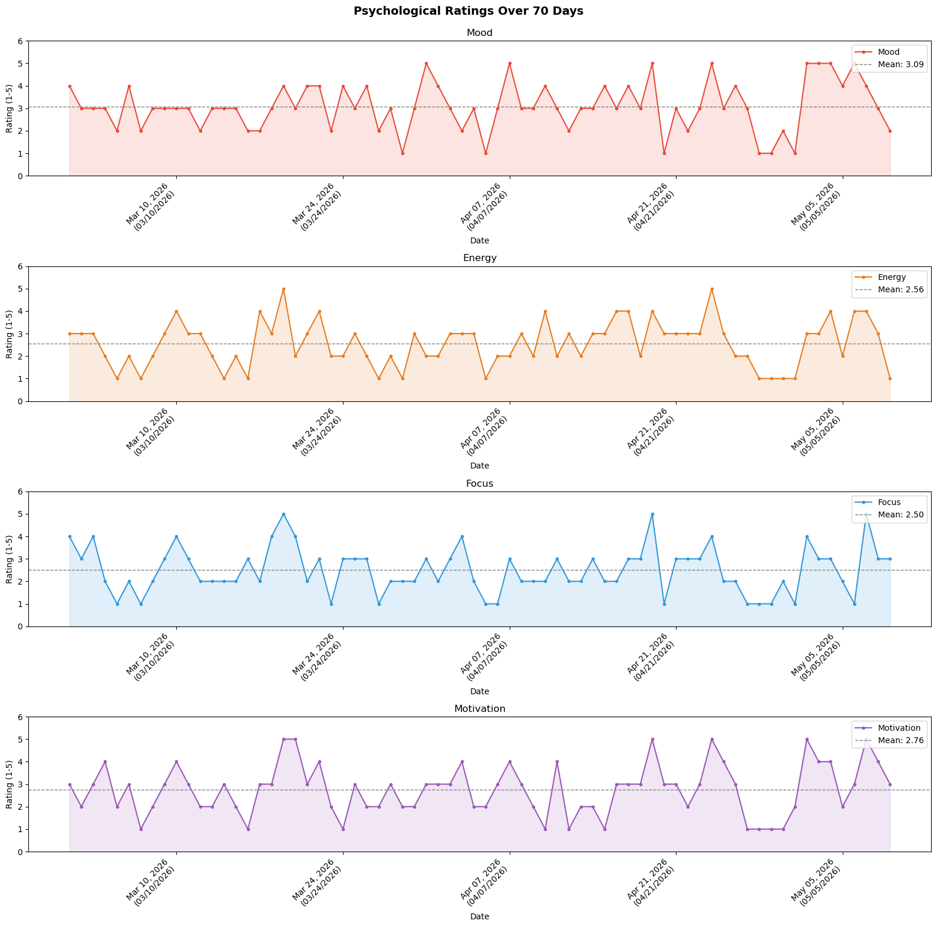
Figure 13: Psychological Ratings Over Time
This coupling suggests that Focus and Motivation function as a unified psychological state during development sessions rather than as independent variables. The subject's qualitative observation supports this interpretation: productive sessions tend to be initiated by engagement with a specific feature or problem, which generates visible progress, which in turn amplifies motivation and deepens focus — a positive feedback loop that sustains and extends sessions well past intended endpoints. The prevalence of Early Morning session starts (71.9% of active days) is a behavioral consequence of this loop, as sessions begun in the evening extend past midnight driven by accumulated momentum rather than by plan.
The near-zero correlations of Mood Rating (r = 0.122) and Energy Level (r = 0.056) with productivity — and their negative regression coefficients (β = −0.217 and β = −0.500 respectively) — further support this interpretation. The subject codes productively regardless of general affect or energy state, and high-energy positive-mood days are more strongly associated with active external obligations than with development sessions. This pattern is consistent with intrinsic motivation theory: when work is genuinely self-determined and passion-driven, external affective states exert minimal influence on output. The finding also carries a personal interpretive dimension. The subject's engagement with mod development traces to age 14, when an initial attempt to learn Java for Minecraft modding was abandoned due to the conceptual barrier of object-oriented fundamentals — particularly access modifiers, class structure, and package organization. This foundational motivation persisted through subsequent years of self-directed learning: JavaScript discovered through a Minecraft: Pocket Edition modding API, which translated into web development proficiency by age 15, culminating in deploying a functional website for a school entrepreneurship project at 17. Java's object-oriented model finally became accessible during the subject's first year of college at 18, at which point the original modding ambition became technically viable. The present data suggest this decade-long sustained motivation — surviving years of detours and a foundational language barrier — remains the primary driver of productivity, more so than any external habit variable measured in this study. The data suggest this foundational motivation remains the primary driver of productivity more than a decade later.
Limitations
This study carries several limitations that bound the generalizability and interpretability of its findings.
Single-subject design: All findings pertain exclusively to one developer. Results cannot be generalized to other developers, chronotypes, or development contexts without replication across multiple subjects.
Caffeine measurement granularity. Daily-total caffeine recording conflates consumption across all contexts — office, gaming, daily routines, and development sessions — limiting the interpretability of any caffeine–productivity relationship.
H2 underpowering. The naturalistic design produced only 4 day sessions across 70 days, making it impossible to test the chronotype hypothesis with adequate statistical power.
Chronic deadline baseline. The persistent Critical deadline pressure maintained by two INC subjects throughout the study period compressed the variance of the deadline variable, limiting H3's statistical detectability.
Self-report bias. Psychological ratings (mood, energy, focus, motivation) are subjective daily assessments subject to recall bias and rating drift over a 70-day period.
Observational design. No variables were experimentally manipulated. Causal claims cannot be made from any observed correlation, including the caffeine and focus findings.
- CONCLUSION
This study investigated the relationship between personal habits and daily mod development productivity over a 70-day longitudinal period, using a single-subject observational design centered on the development of Defensive Measures, a published Minecraft Java-Fabric modification. Three hypotheses were tested examining caffeine intake, work session timing, and deadline pressure as predictors of voluntary development output.
None of the three hypotheses were supported in their originally predicted form. H1, which predicted a null caffeine–productivity relationship attributable to high habitual tolerance, was technically rejected by a marginally significant positive correlation (r = 0.352, p = 0.048 on active days) — but this correlation is most parsimoniously explained by common-cause bias, measurement granularity limitations, and the near-zero regression coefficient assigned to caffeine once psychological variables were controlled (β = +0.001). H2, which predicted higher productivity during night sessions, could not be evaluated due to an insufficient daytime comparison group which itself is a meaningful finding, as the 87.5% night session rate behaviorally confirms the subject's deeply entrenched nocturnal chronotype. H3, which predicted deadline-driven displacement of mod development hours, showed the correct directional trend (r = −0.194) but failed statistical significance due to a chronic Critical deadline baseline that compressed the variable's measurable range throughout the study period.
The most consistent and actionable finding across all analyses is the primacy of Focus Quality and Motivation Level as productivity predictors. Together these two variables dominated the regression model (β = +1.176 and β = +0.498 respectively) and were strongly intercorrelated (r = 0.650), suggesting they function as a unified psychological state during development sessions. The near-zero correlations of Mood Rating and Energy Level with productivity output — and their negative regression coefficients — further indicate that this subject's development productivity is driven by intrinsic engagement rather than general affective state. The model's R² of 0.32 leaves substantial unexplained variance attributable to unmeasured factors including development milestones, feature complexity, and the self-reinforcing feedback loop between progress and motivation that sustains late-night sessions well past intended endpoints.
Taken together, the findings paint a portrait of a developer whose productivity is fundamentally intrinsic in nature — resistant to external affective conditions, sustained across years of detours and technical barriers, and most reliably predicted by the degree to which he is cognitively locked into the work. For this subject, the most actionable insight is not to regulate caffeine or sleep more, but to protect and cultivate conditions that enable deep focus — the single variable most associated with productive output across the entire study.
Future research should extend this methodology to multiple subjects across different chronotypes and development contexts, incorporate session-specific caffeine tracking rather than daily totals, and include deliberate experimental manipulation of work session timing to enable proper chronotype hypothesis testing. The self-tracking methodology demonstrated here is replicable by any independent developer seeking data-driven insight into their own productivity patterns.
- REFERENCES

[1] | N. Forsgren, M.-A. Storey, C. Maddila, T. Zimmermann, B. Houck and J. Butler, "The SPACE of Developer Productivity," The SPACE of Developer Productivity: There's more to it than you think., vol. 19, no. 1, 2021.
[2] | A. Kapellou, L. Pilic and Y. Mavrommatis, "Habitual caffeine intake, genetics and cognitive performance," Journal of psychopharmacology (Oxford, England), vol. 39, no. 3, p. 233–243, 2025.
[3] | R. West, R. T. C. Wong, J.-E. Park, S. W. Lee, D. E. Mudiyanselage, Z. Liu and D. Ma, "Sleep duration, chronotype, health and lifestyle factors affect cognition: a UK Biobank cross-sectional study," BMJ Public Health, vol. 2, no. 1, 2024.
[4] | Y. Zhang, H. Qu, F. Walter and W. Liu, "A new perspective on time pressure and creativity: Distinguishing employees' radical versus incremental creativity," Journal of Organizational Behavior, vol. 44, no. 9, pp. 1400-1418, 2023.

